
National College of Computer Studies
Paknajol, Kathmandu

Report on Fitness Tracker

Submitted by: Ashmi Maskey Submitted to:
Programme: BSc. CSIT Janak Raj Joshi
Section: B OOP Lecturer
Roll No: 03
Email: maskeyashmi@gmail.com

Declaration
I hereby declare that the project work entitled “Fitness Tracker” submitted to Institute of Science and Technology, Tribhuvan University, Kathmandu. National College of Computer Studies, Kathmandu, is for the degree that is submitted in partial fulfillment of requirements for the degree of Bachelor of Science in Computer Science and Information Technology (Bsc.CSIT). This report contains all the original research and analysis with some information taken from other resources which are properly cited. This project work has not been submitted to any other university or institution for the award of any degree or diploma.

……………………………………………
Ashmi Maskey

Acknowledgment

This report is my assignment as a partial fulfillment of project work course for the requirement of Bachelor of Science in Computer Science and Information Technology (Bsc.CSIT). I have taken this opportunity to express my respect and gratitude to my respected teacher Mr. Janak Raj Joshi for his valuable guidance in making this project a reality. I am thankful for their constant support and encouragement and valuable guidance and encouragement throughout this project completion period. I am also thankful to the lab teacher Kajol Ramtel for her help during the completion of the project. I would like to present my teachers gratitude for their guidance, good advice and honest reviews in this entire project session. Project has been completed under the intensive and genuine guidance of the National College of Computer Studies.

………………………….

Ashmi Maskey
National College of Computer Studies

Table of Contents
1. Introduction 1
2. Objective 1
2.1. Health Tracking: 1
2.2. Object-Oriented Design: 1
2.3. User-Friendly Interaction: 1
2.4. Health Metric Calculations: 1
2.5. Encouraging a Healthier Lifestyle: 1
3. Problem definition and analysis 2
4. Methodology 2
5. System design and development 3
5.1. My Source Code: 3
5.2. Output 6
6. Conclusion 7
7. User Manual 7
8. References 8

List of Figures

Figure 1: header file. Preprocessor and Class 3
Figure 2: function 3
Figure 3: function part-II 4
Figure 4 switch case 4
Figure 5 File handling 4
Figure 6 main() function part-I 5
Figure 7 main() function part-II 5
Figure 8 main() function part-III 5
Figure 9: Output I 6
Figure 10 Output II 6
Figure 11: Output III 6
Figure 12: Output IV 6
Figure 13: Output V 6

Abstract
The "Fitness Tracker Implementation in Object Oriented Programing" emerges as a holistic solution to empower individuals in their journey towards a healthier lifestyle. This projects unveils a multifaceted approach to fitness, encompassing the tracking of water intake, steps, calorie consumption, and personalized exercise recommendations.
The Fitness Tracker offers users a seamless and intuitive interface to log their daily activities and receive tailored exercise suggestions. By tracking fundamental metrics such as water intake, steps walked, and calorie consumption, the system provides a comprehensive overview of an individual's daily health habits.

Introduction
The Fitness Tracker System, constructed with OOP at its core, embodies this philosophy. By encapsulating data and functionalities into classes and objects, we've sculpted a system that not only accurately logs your fitness journey but also promotes extensibility, maintainability, and code reusability.

Objective
The primary objective of the Fitness Tracker is to provide individuals with a comprehensive and user-centric platform for managing and enhancing their overall fitness and well-being. This project seeks to achieve the following key goals:

Health Tracking:
Enable users to systematically log and track essential health parameters, including daily steps, water intake, calorie consumption, and workout sessions.

Object-Oriented Design:
Embrace Object-Oriented Programming (OOP) principles to create a modular, extensible, and maintainable codebase, enhancing the system's scalability and adaptability. [1]

User-Friendly Interaction:
Develop an intuitive and user-friendly interface that facilitates seamless interaction, making it easy for users to log data, view statistics, and receive personalized workout suggestions.

Health Metric Calculations:
Integrate calculations for essential health metrics such as Body Mass Index (BMI) and ideal weight, providing users with valuable insights into their physical well-being.

Encouraging a Healthier Lifestyle:
Motivate and empower users to make informed decisions about their health, instilling a sense of accountability and encouragement on their fitness journey. [2]

Problem definition and analysis
Traditional methods of tracking, lacking intelligent analysis, often fall short in providing tailored recommendations, hindering users from achieving their fitness goals.
Fragmented Health Tracking:
Many individuals rely on disparate tools and methods to log daily activities such as steps, water intake, and workouts. The lack of integration leads to an incomplete and disjointed view of their overall health.
Data Overload and Disorganization:
Users may feel overwhelmed by the sheer volume of health data they accumulate, leading to a lack of clarity and actionable insights. Disorganized information makes it challenging for individuals to discern meaningful patterns. [2]
Inefficient BMI and Ideal Weight Calculations:
Calculations for key health metrics like Body Mass Index (BMI) and ideal weight may be absent or inaccurately implemented in some solutions, depriving users of valuable health assessments. [3]Through intelligent data tracking, personalized recommendations, and the implementation of Object-Oriented Programming principles, the project aims to transform fragmented fitness tracking into a seamless and user-centric experience, empowering individuals to take control of their health journey.

Methodology
a. Requirement Analysis:
- Objective: Understand the user's needs and expectations.
- Activities:
  - Conduct surveys and interviews to gather user preferences.
  - Identify key features, such as health metrics tracking, activity logging, and personalized recommendations.
  - Define user personas and scenarios.
b. System Design:
- Objective: Plan the architecture and functionality of the Fitness Tracker.
- Activities:
  - Define the database schema for storing user data.
  - Design the user interface for an intuitive and engaging experience.
  - Specify algorithms for BMI calculation, workout recommendations, and data analysis.
c. Development:
- Objective: Implement the planned features and functionalities.
- Activities:
  - Implement backend logic using a OOP.
d. Integration:
- Objective: Combine frontend, backend, and database components into a unified system.
- Activities:
  - Perform unit testing to ensure individual components work as intended.
  - Integrate components and conduct system-level testing.

System design and development
For data storage, the amount of storage used to store the program's data, including any variables or objects used by the program is the size of the data storage, that will depend on the size and number of the variables and files used by the program.[3]

My Source Code:
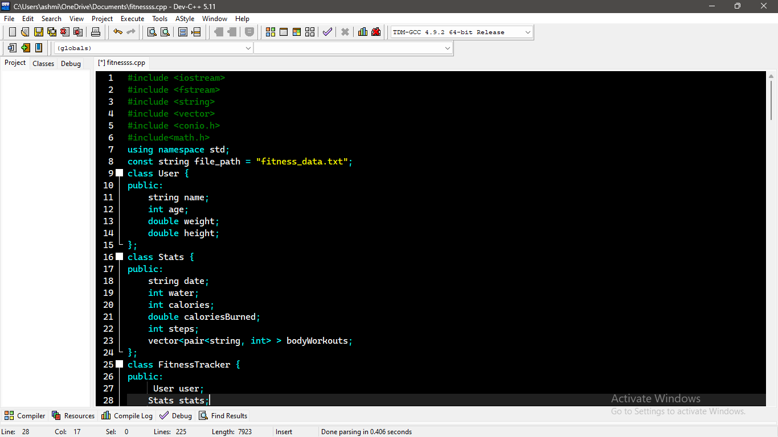
Figure 1: header file. Preprocessor and Class
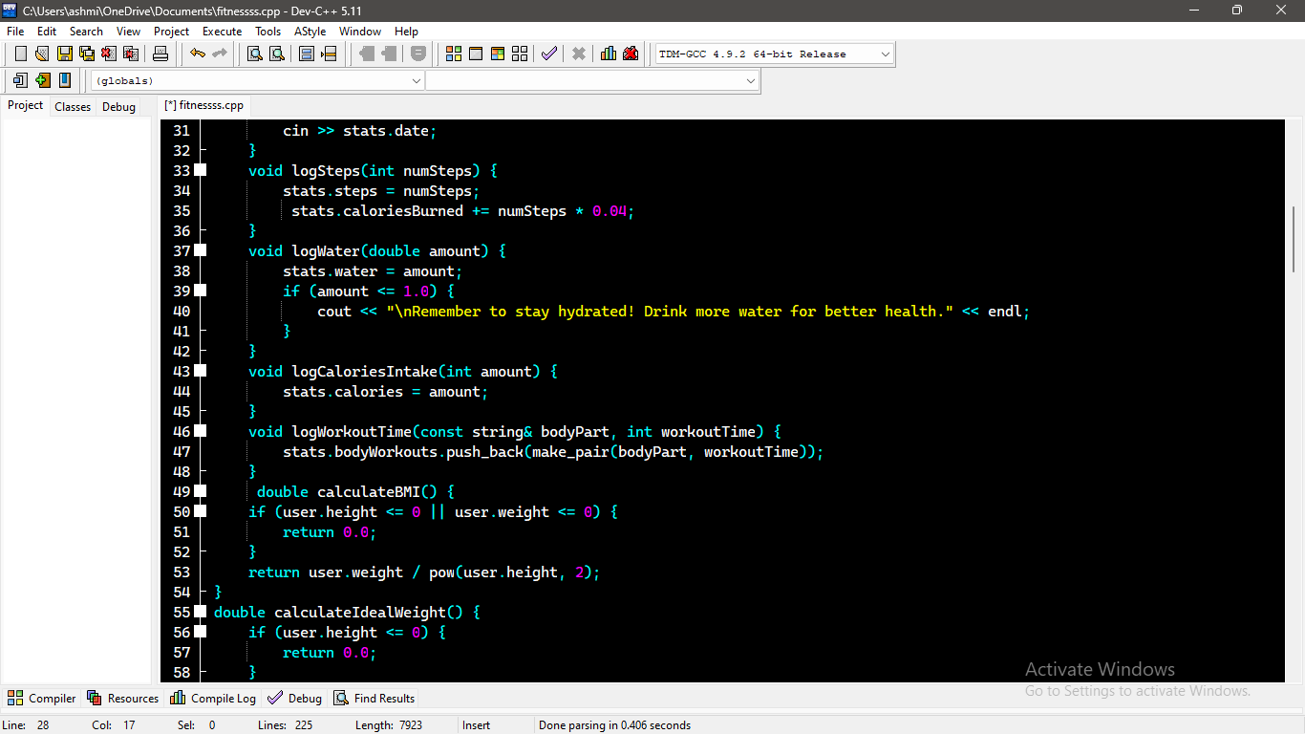
Figure 2: function

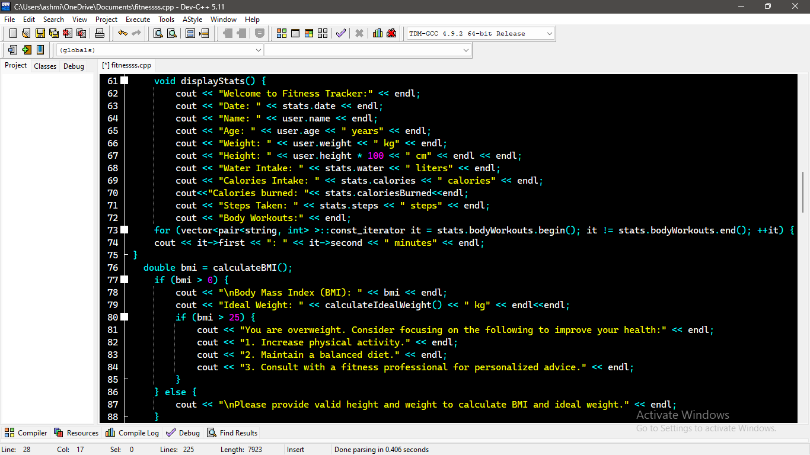
Figure 3: function part-II
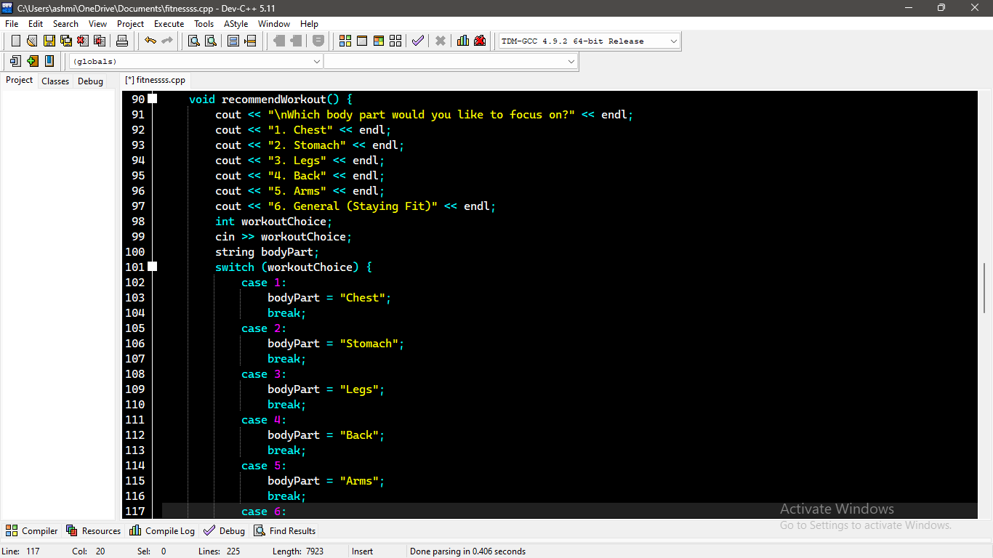
Figure 4 switch case
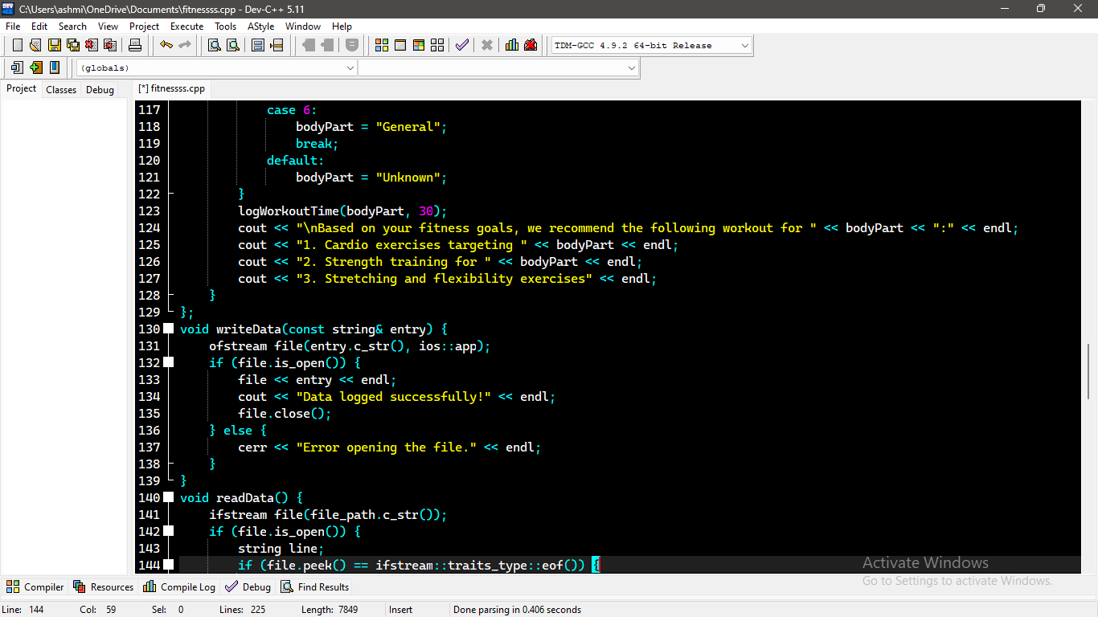
Figure 5 File handling
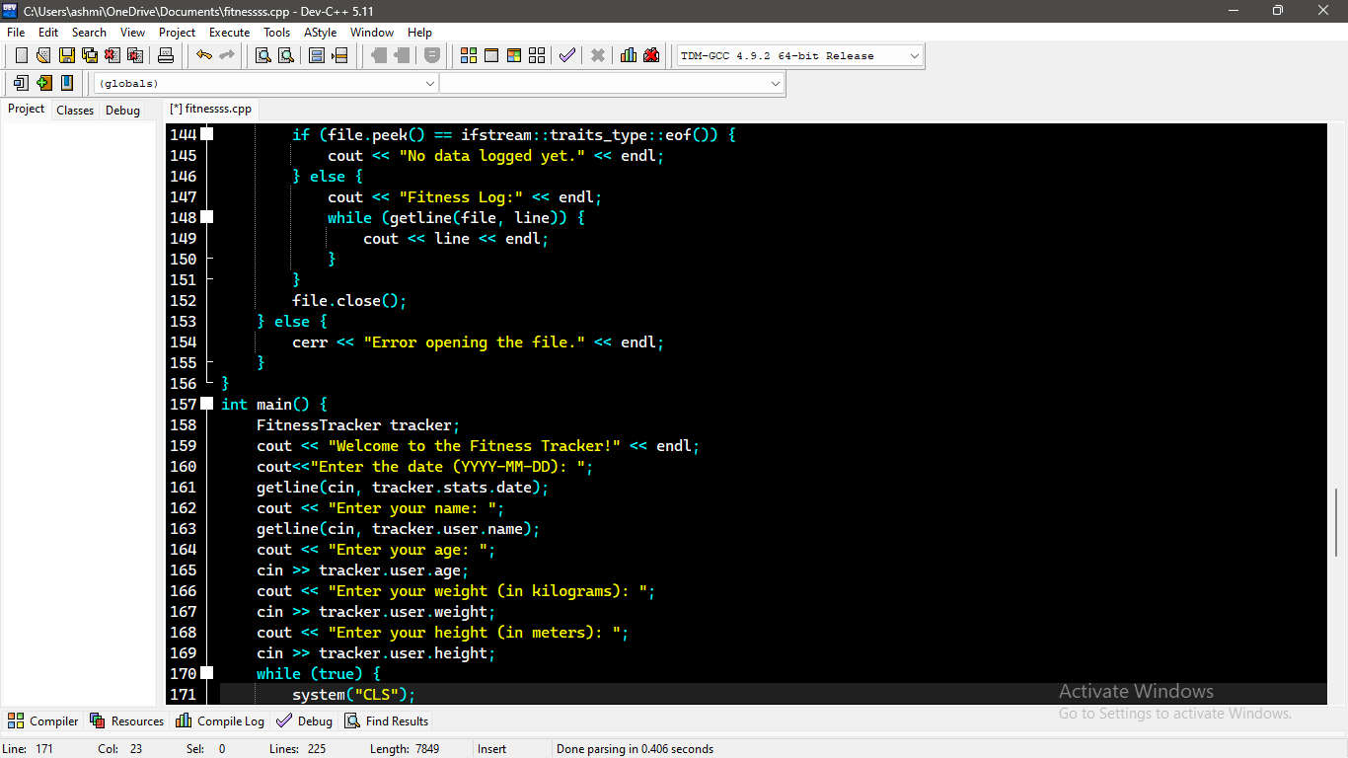
Figure 6 main() function part-I
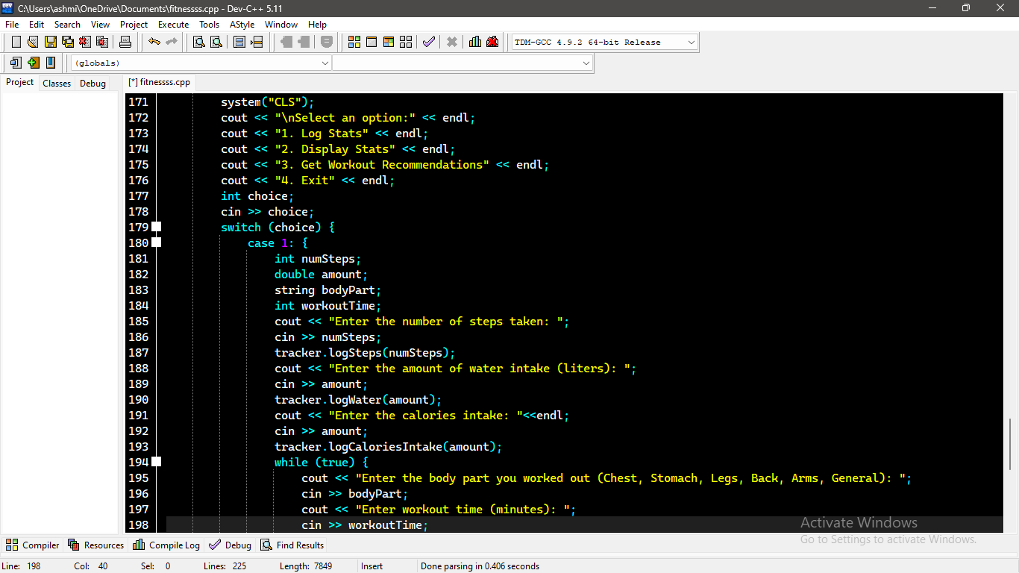
Figure 7 main() function part-II
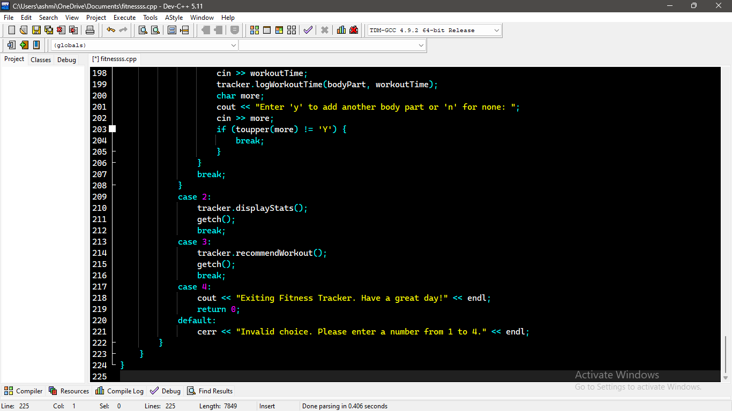
Figure 8 main() function part-III

Output
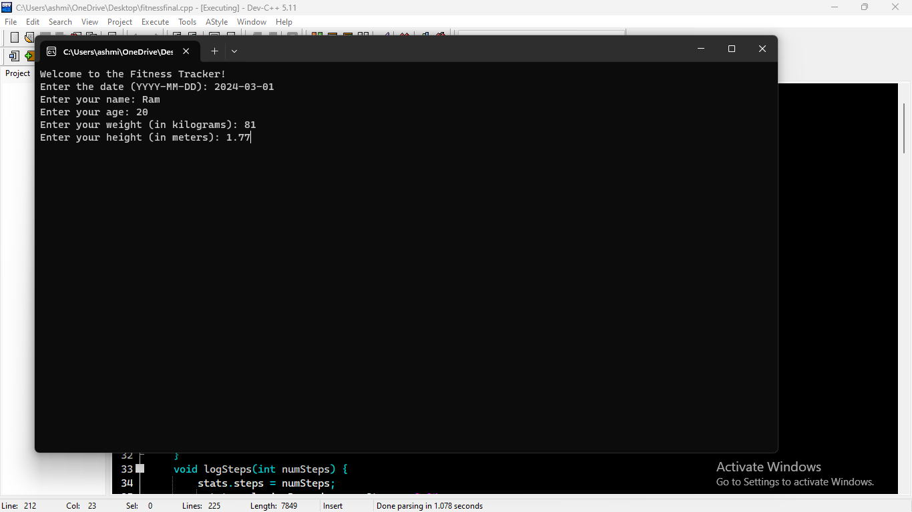
Figure 9: Output I
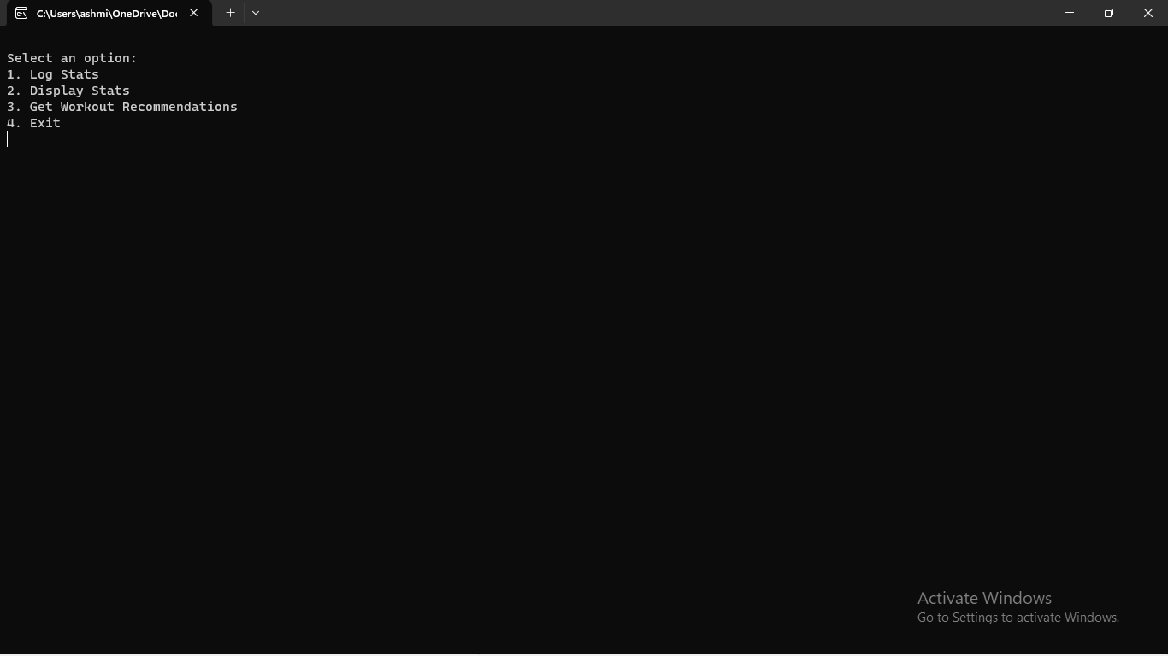
Figure 10 Output II
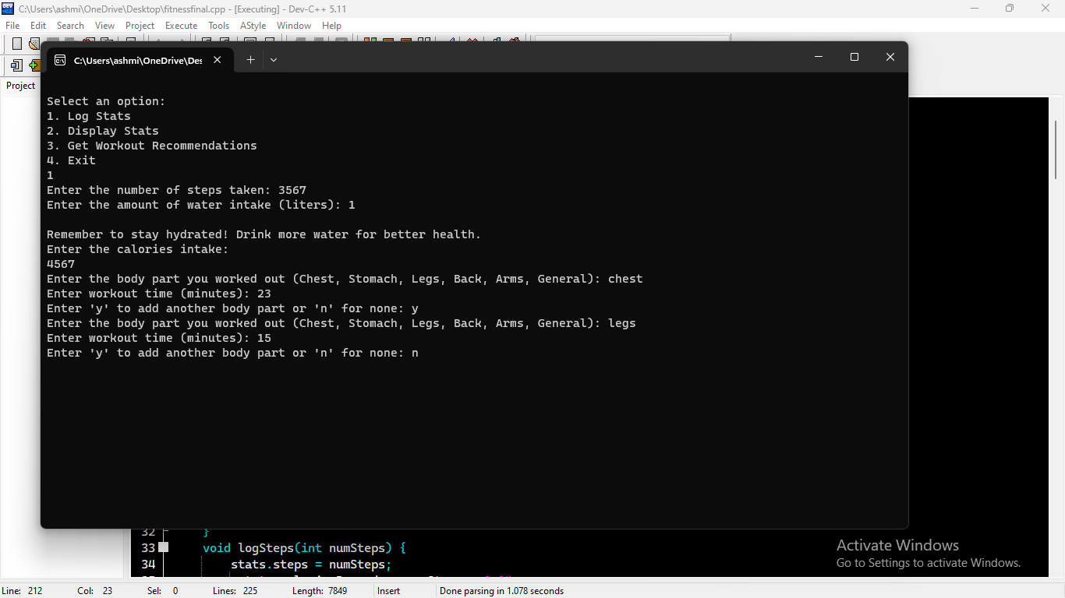
Figure 11: Output III
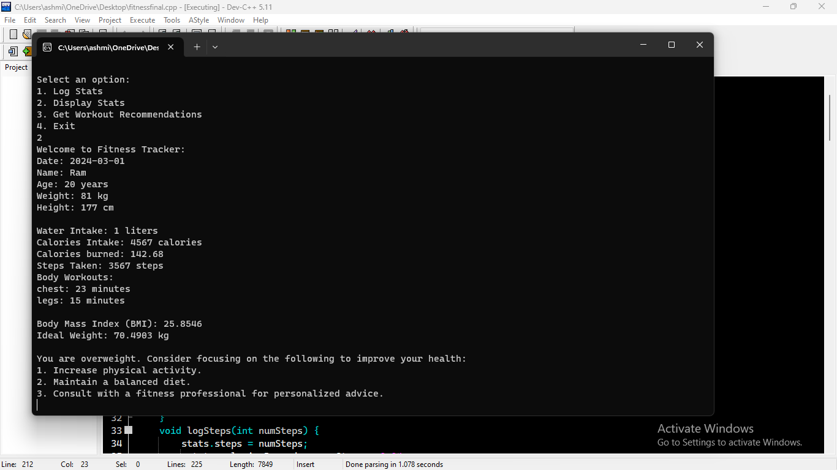
Figure 12: Output IV
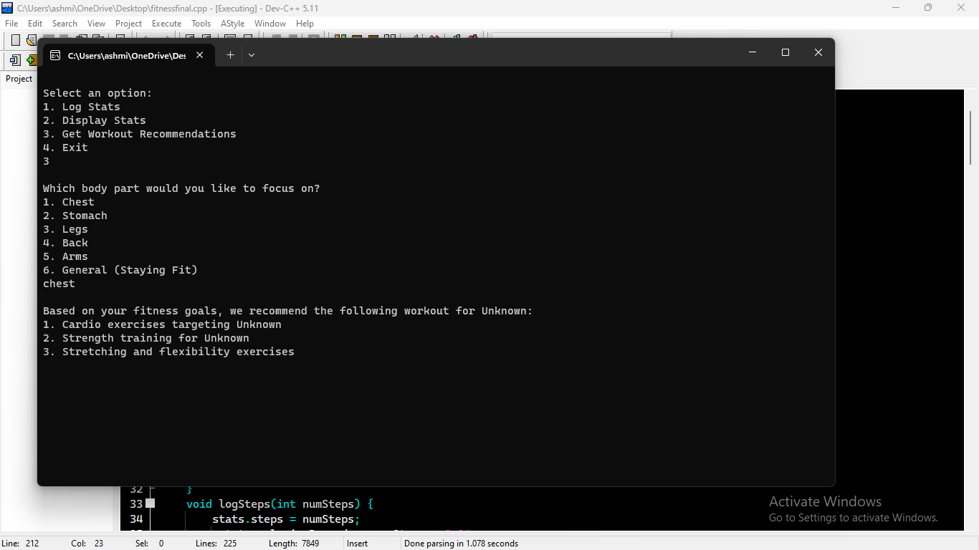
Figure 13: Output V

6.Conclusion
In creating the Fitness Tracker, the goal was to make a helpful tool for people to manage their health. Using smart technology and easy-to-understand menus, we designed a system that not only tracks your steps and workouts,
By keeping things simple and organized,. This system is not just about numbers; it's like a friendly guide encouraging you to make healthy choices every day. [2]

User Manual

Enter Personal Information:
  - When prompted, enter the date, your name, age, weight (in kilograms), and height (in meters).
  - The date should be in the format YYYY-MM-DD.
Main Menu:
  - After entering your details, you'll be presented with the main menu, where you can choose different options.
Options
a. Log Stats
- Steps: Enter the number of steps you've taken in a day.
The program will calculate calories burned based on the steps.
- Water Intake: Input the amount of water you've consumed in liters.
- Calories Intake: Log the number of calories you've consumed.
- Workout Details:
- Specify the body part worked out (Chest, Stomach, Legs, Back, Arms, General).
- Enter the workout time in minutes.
- Repeat for additional body parts if necessary.
b. Display Stats
- View a summary of your fitness stats, including water intake, calories intake, calories burned, steps taken, and body workouts.
- Calculate and display Body Mass Index (BMI) and Ideal Weight.
  - BMI is an indicator of body fat based on your weight and height.
  - Ideal Weight is a target weight for a healthy BMI.
- Get recommendations based on your BMI:
  - If BMI is over 25, receive suggestions for improvement.
c. Get Workout Recommendations
- Choose a body part to focus on (Chest, Stomach, Legs, Back, Arms, General).
- Receive workout recommendations based on your fitness goals.
d. Exit
- Exit the Fitness Tracker program.

8.References

[1] | "C++ board," [Online]. Available: https://board.cprogramming.com/.
[2] | "Geeks for Geeks," [Online]. Available: https://www.geeksforgeeks.org/c-programming-language/.
[3] | "learn c++," [Online]. Available: https://www.learn-c++.org/.
[4] | "Programmiz," [Online]. Available: https://www.programiz.com/c++-programming.
[5] | "Stack overflow," [Online]. Available: https://stackoverflow.com/.
[6] | "w3 school," [Online]. Available: https://www.w3schools.com/.
[7] | "cpluscplus," [Online]. Available: https://cplusplus.com/.
[8] | [Online]. Available: https://www.learncpp.com/ .

